# **Introduction**

# **Summary of Levels**

1. Rescue Storm

2. Rescue Cyclops

3. Rescue Jean Grey

4. Rescue Beast

5. Rescue Colossus

6. Rescue Shadowcat

7. Rescue Rogue

8. Rescue Iceman

9. Rescue Mystique

10. Rescue Nightcrawler

11. Rescue Jubilee

12. Rescue Quicksilver

13. Rescue Professor X

14. Rescue Siryn

15. Rescue Artie Maddicks

16. Rescue Jones

17. Rescue Flea

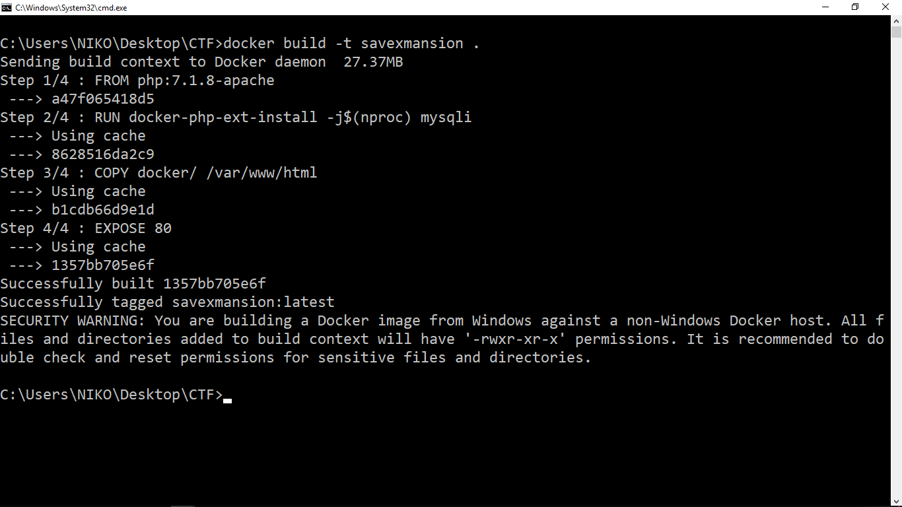

**C:\Users\NIKO\Desktop\CTF>docker run -p 80:80 --link dbLogan --network era --name xmansion savexmansion**

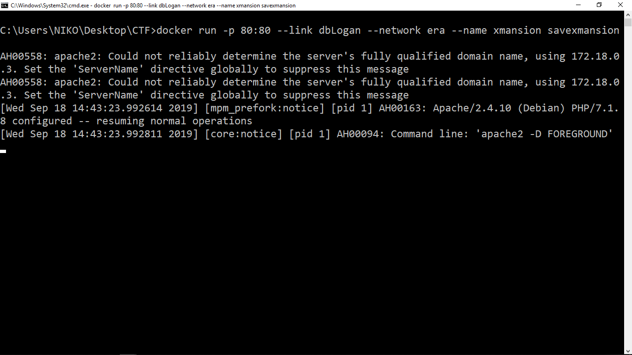

**C:\Users\NIKO\Desktop\CTF\db>docker build -t my-mysql .**

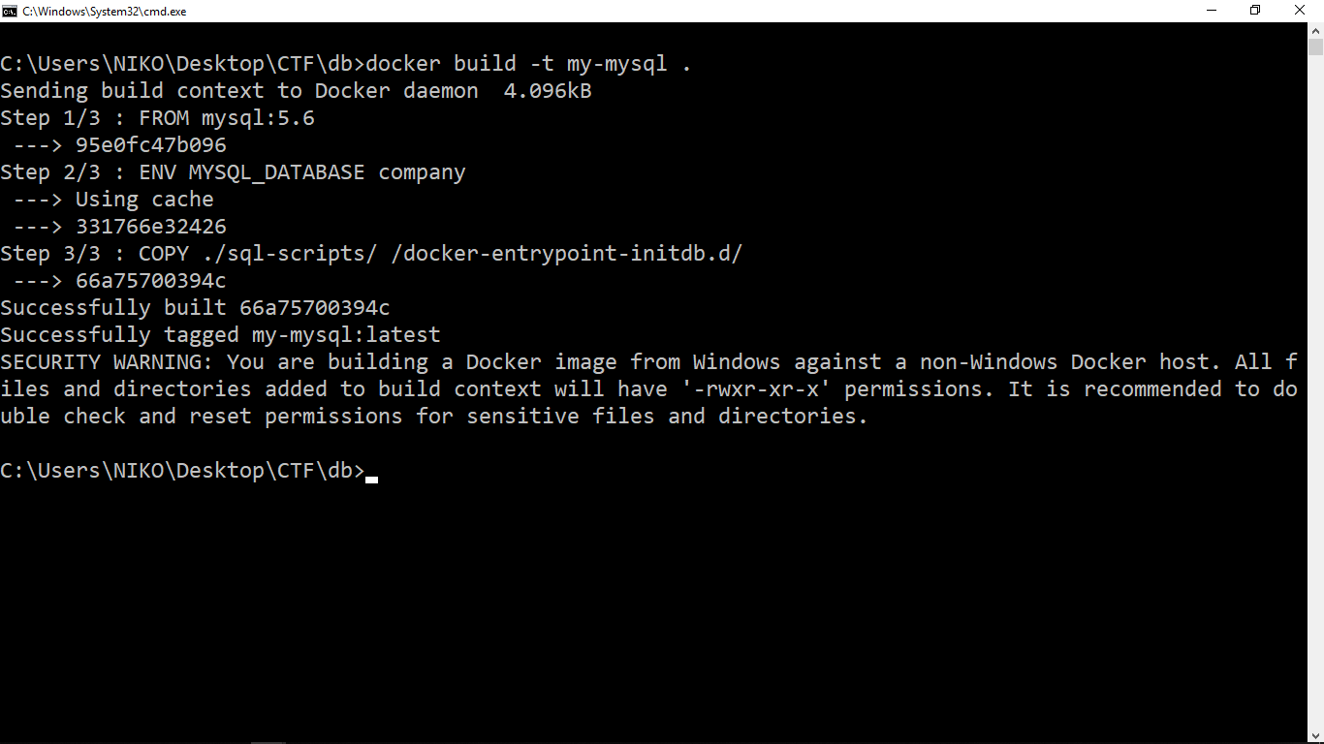

**C:\Users\NIKO\Desktop\CTF\db>docker run -it -p 3306:3306 --name dbLogan --network era -e MYSQL_ROOT_PASSWORD=123 my-mysql**

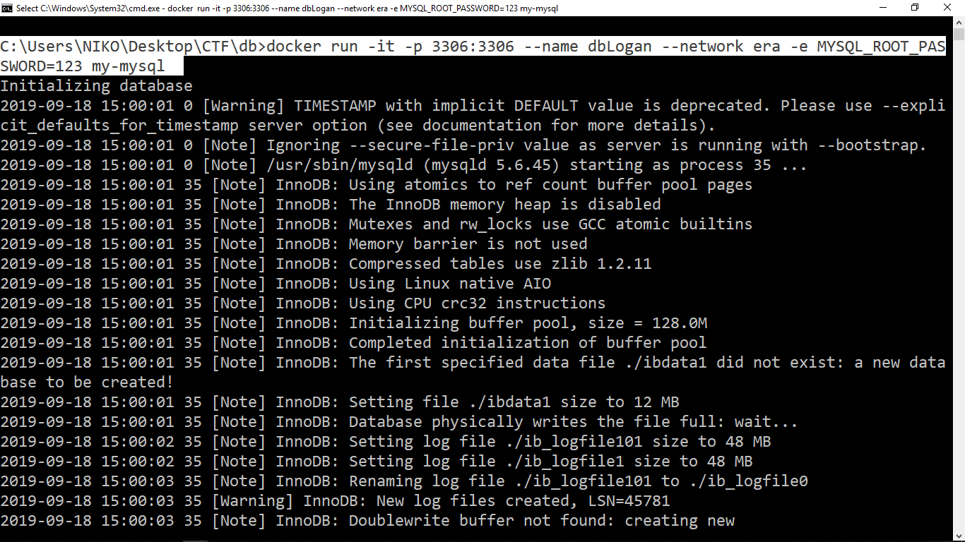

# **Level 01**

<http://localhost/level1.php>

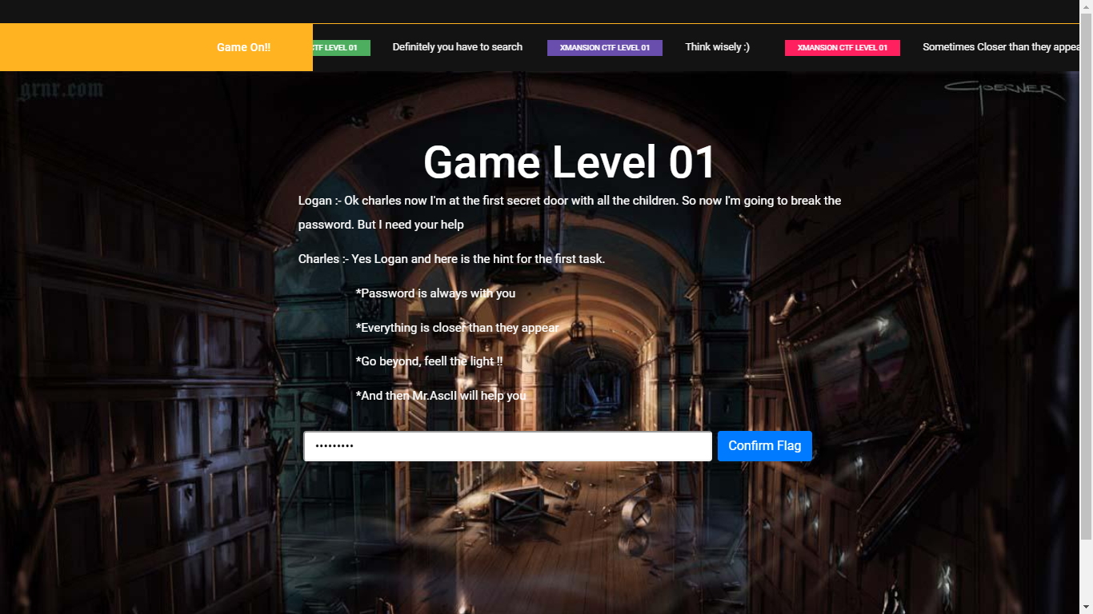

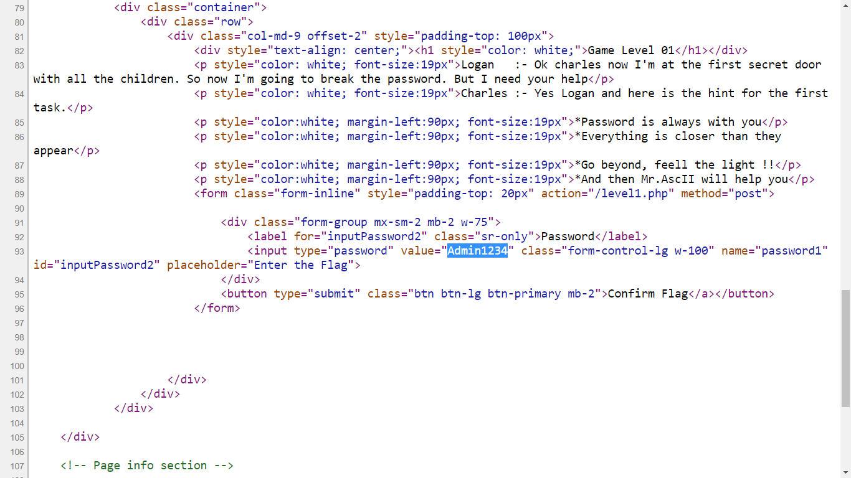

<http://www.unit-conversion.info/texttools/ascii/>

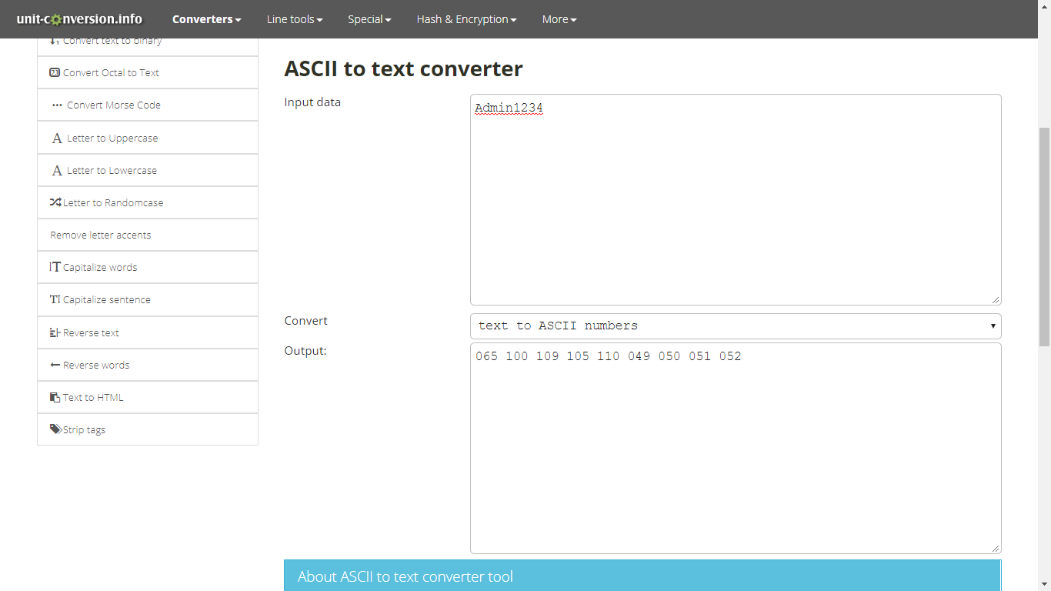

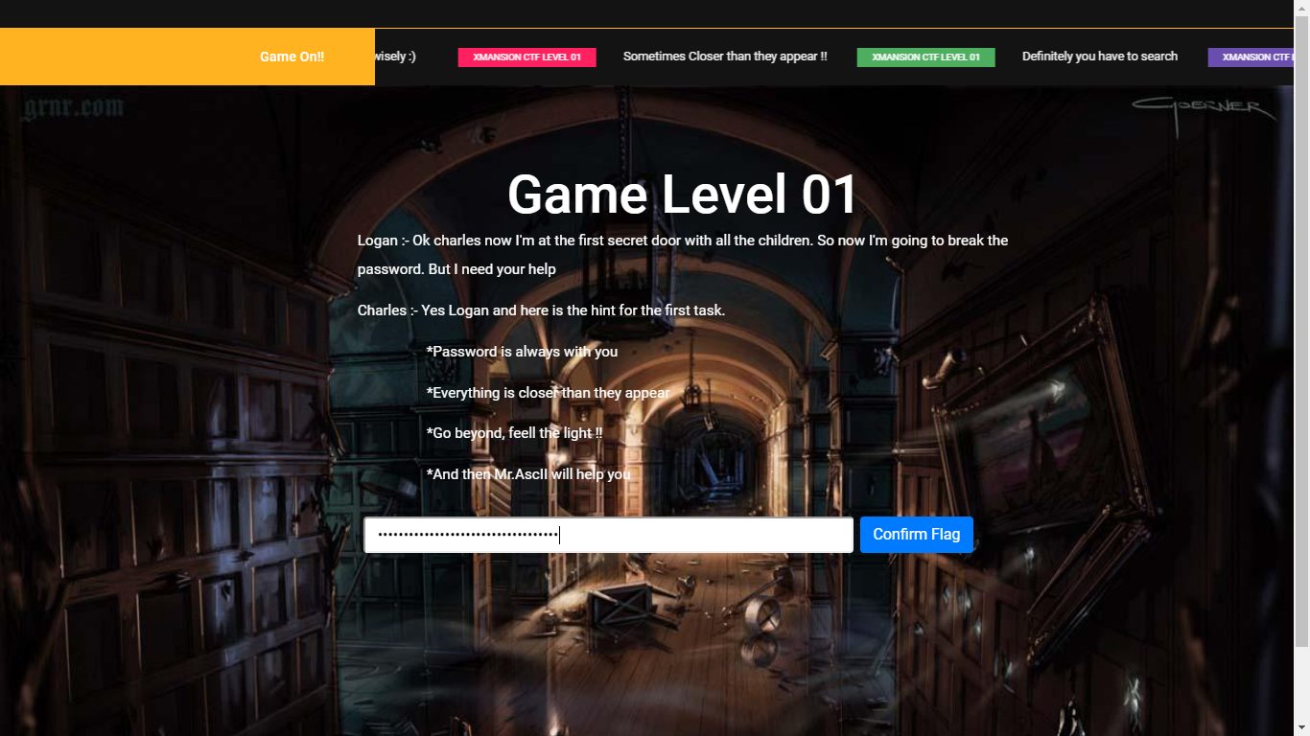

# **Level 02**

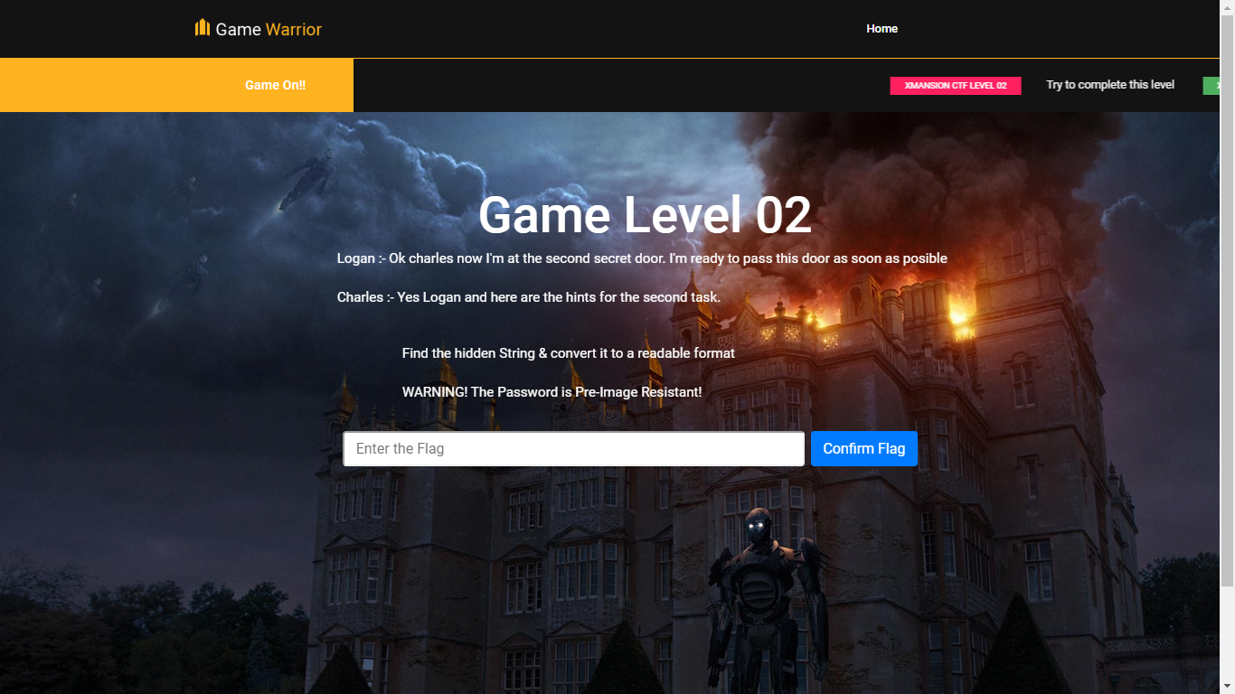

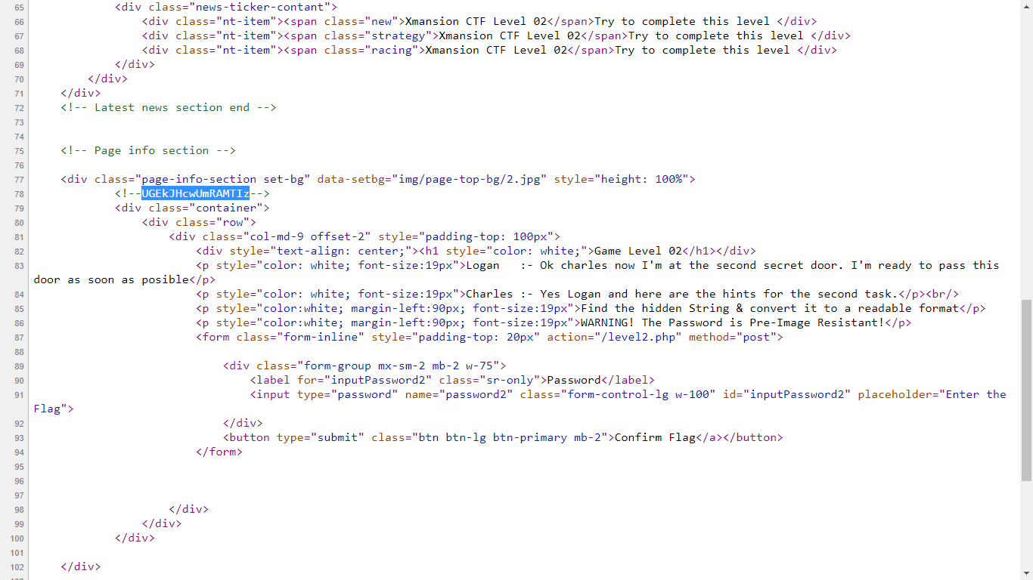

<https://www.base64decode.org/>

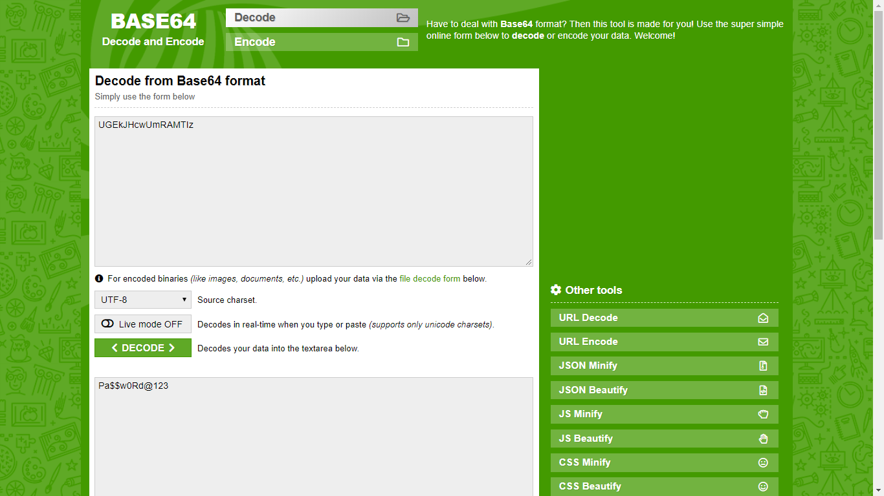

<https://timestampgenerator.com/tools/sha256-generator>

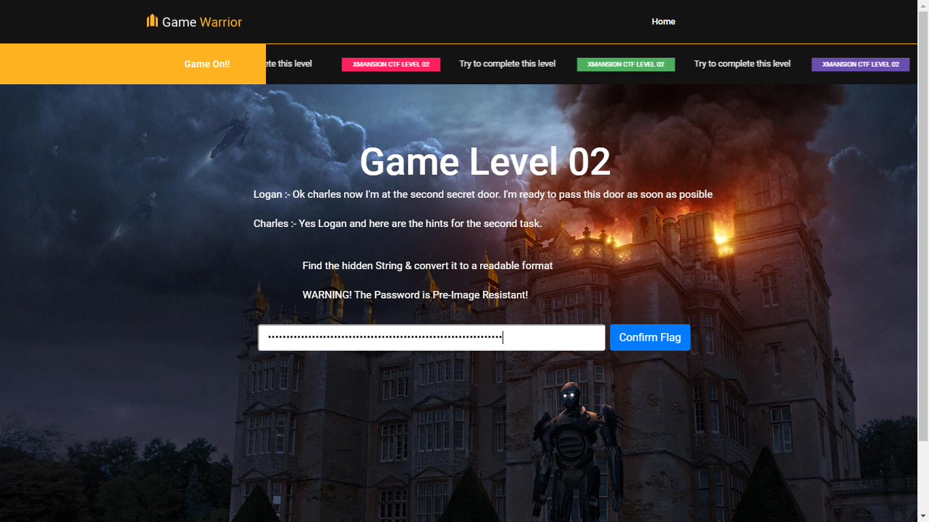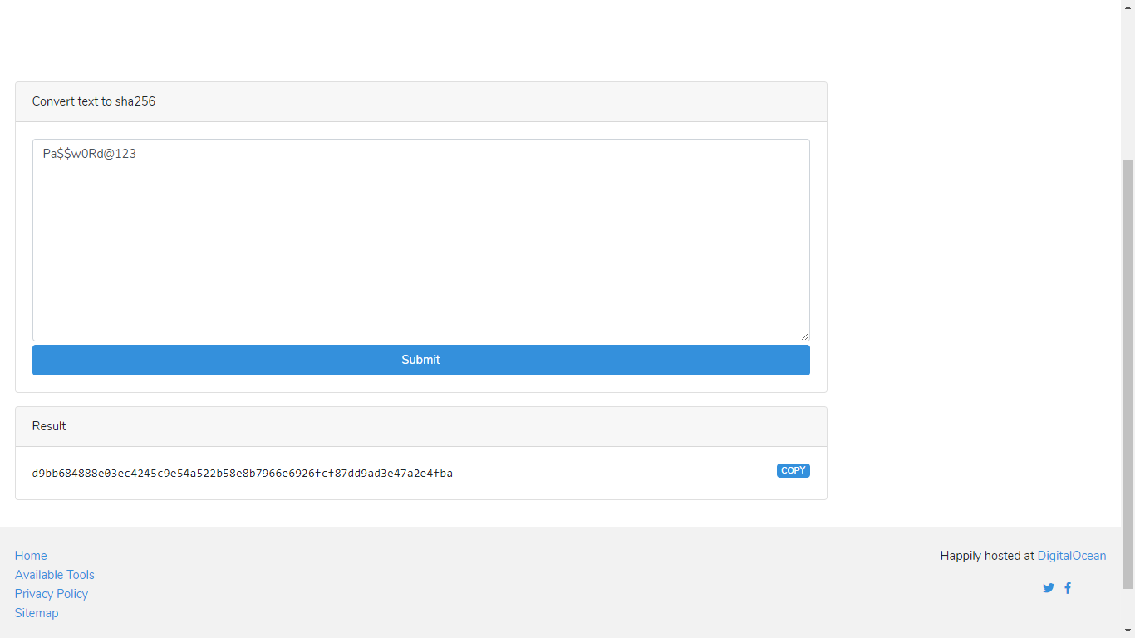

# **Level 03**

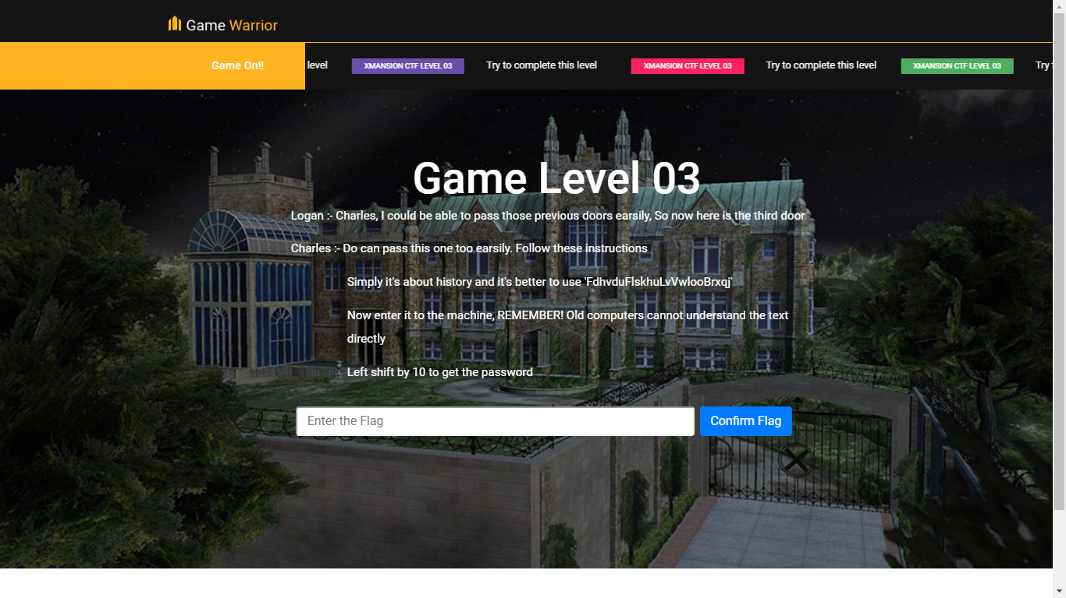

<https://cryptii.com/pipes/caesar-cipher>

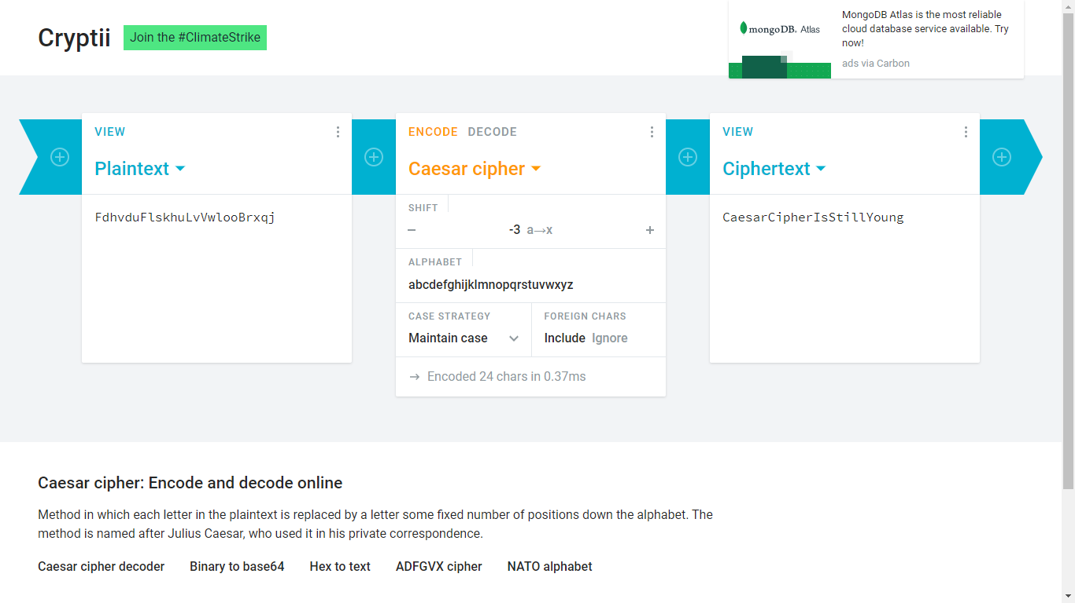

<https://www.rapidtables.com/convert/number/ascii-to-binary.html>

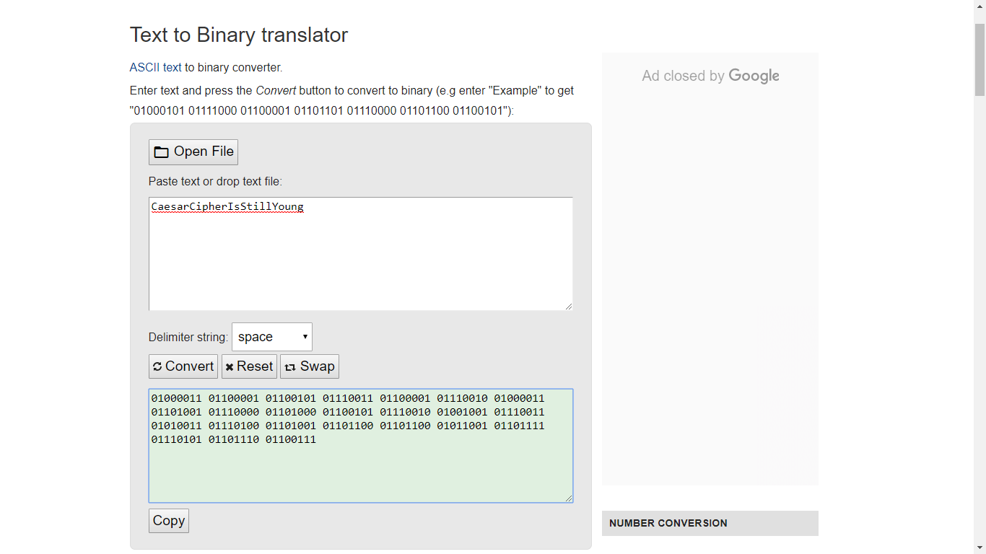

**01000011 01100001 01100101 01110011 01100001 01110010 01000011 01101001 01110000 01101000 01100101 01110010 01001001 01110011 01010011 01110100 01101001 01101100 01101100 01011001 01101111 01110101 01101110 01100111**

**010000110110000101100101011100110110000101110010010000110110100101110000011010000110010101110010010010010111001101010011011101000110100101101100011011000101100101101111011101010110111001100111**

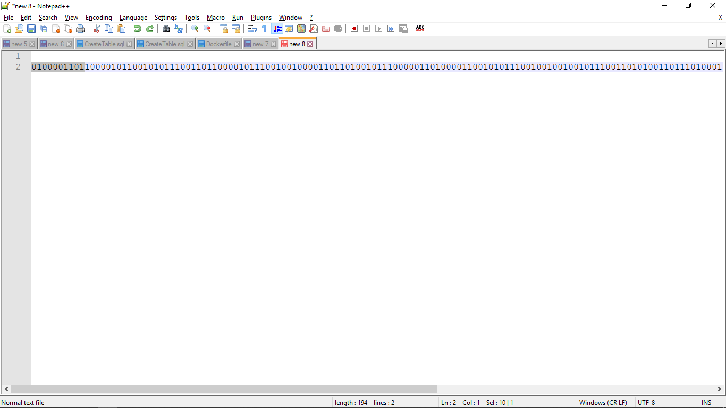

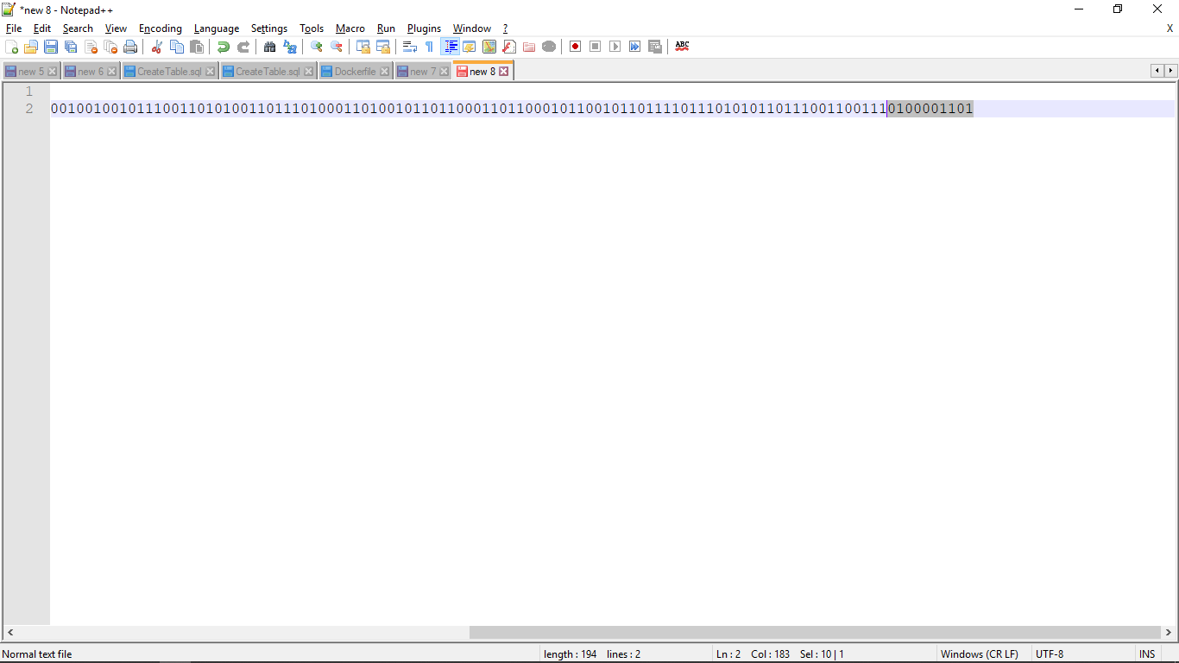

**000111001011110011110000111100101000011110100111100001101000110010111100101001001111001110100111110100110100111011001101100101100111011111110101110111011001111000011110**

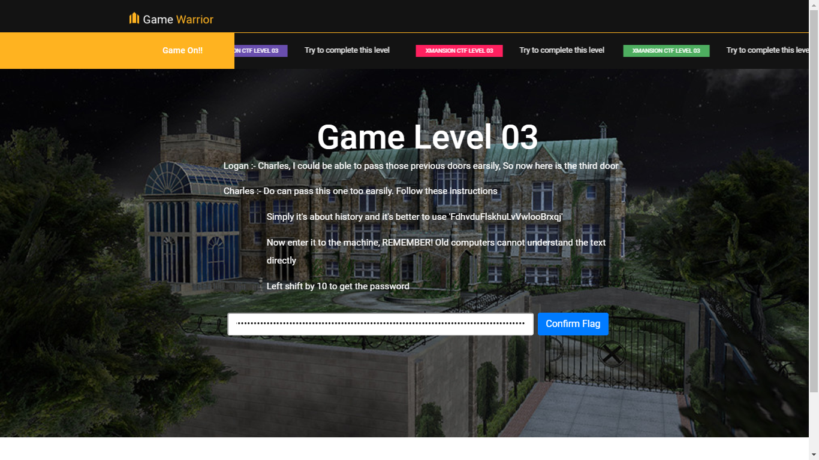

# **Level 04**

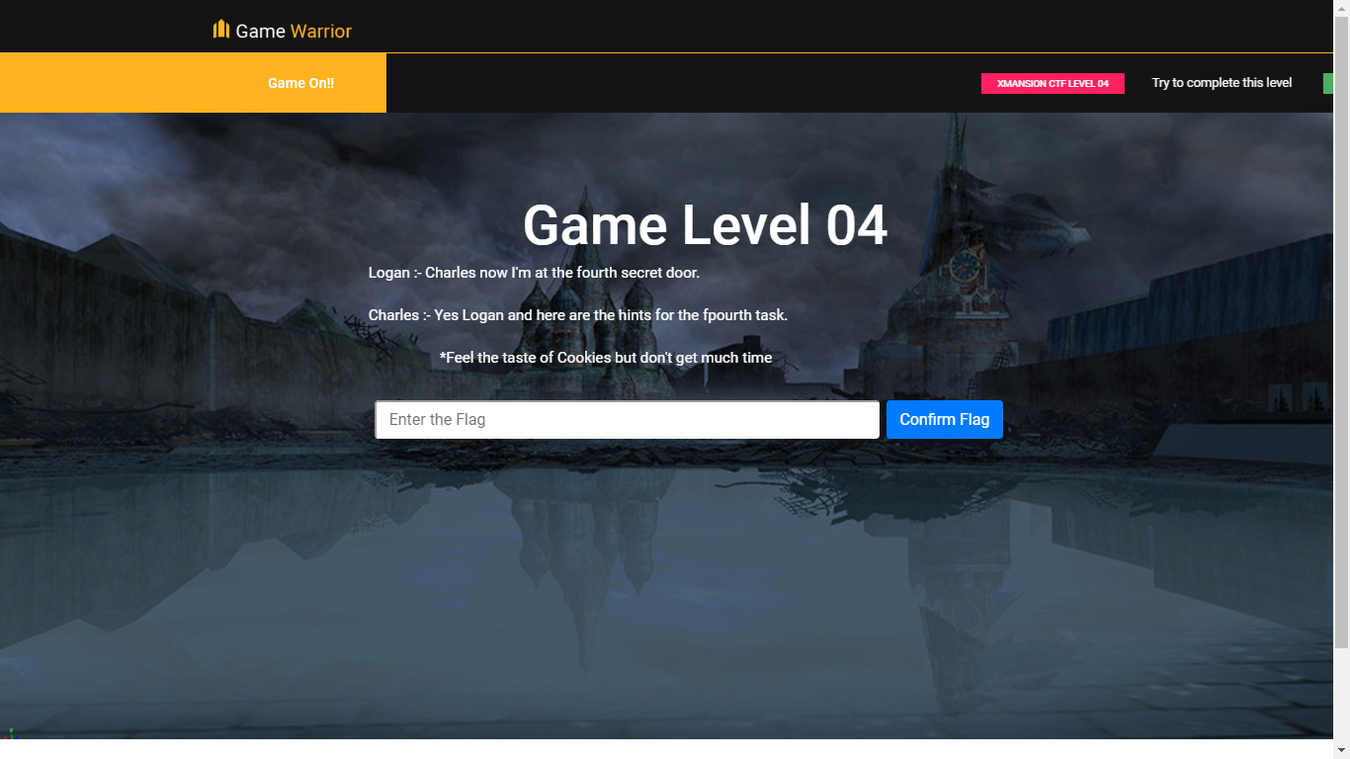

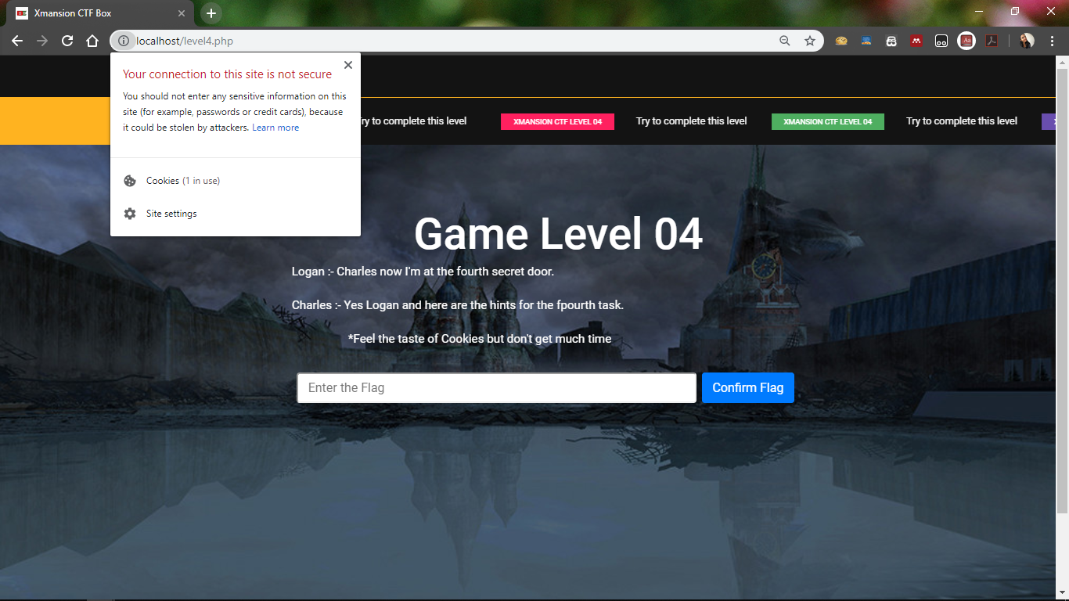

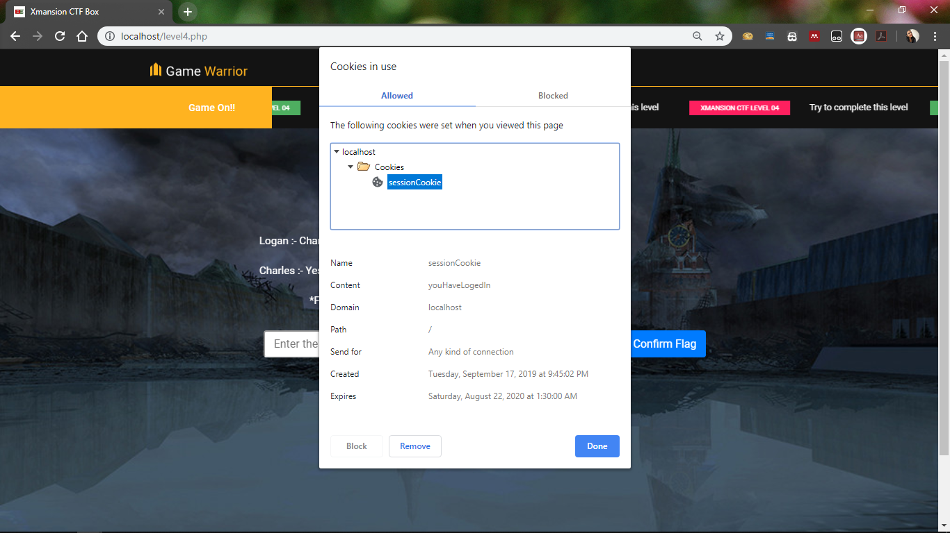

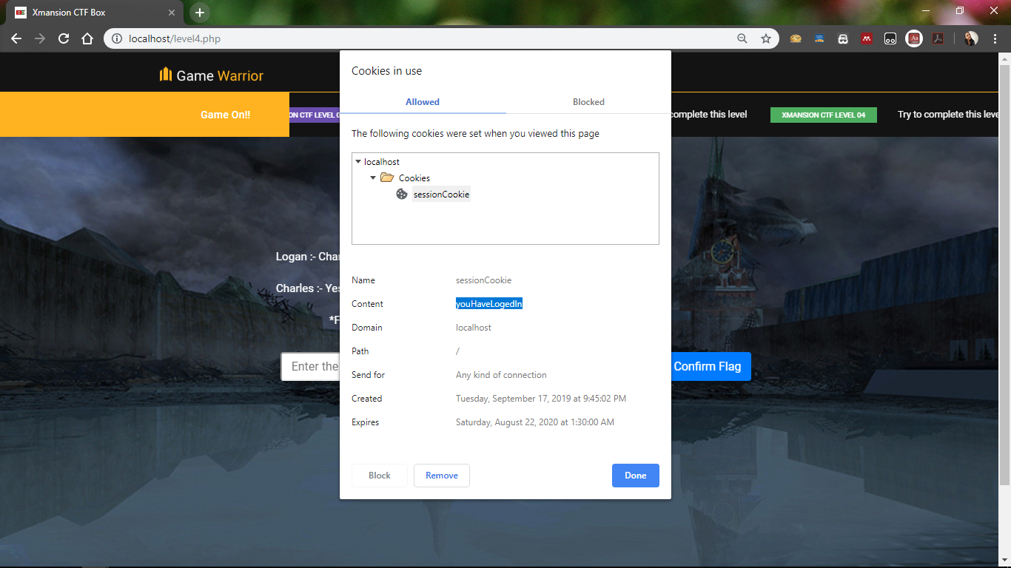

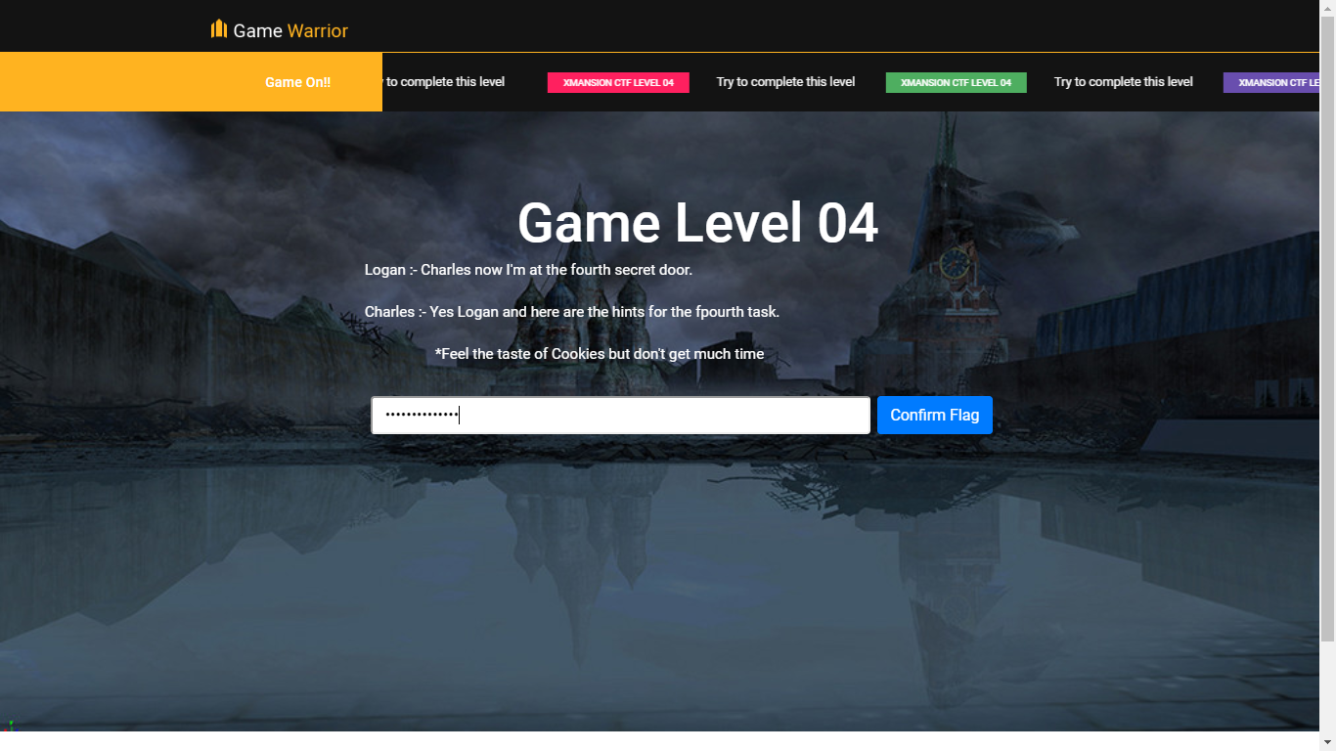

# **Level 05**

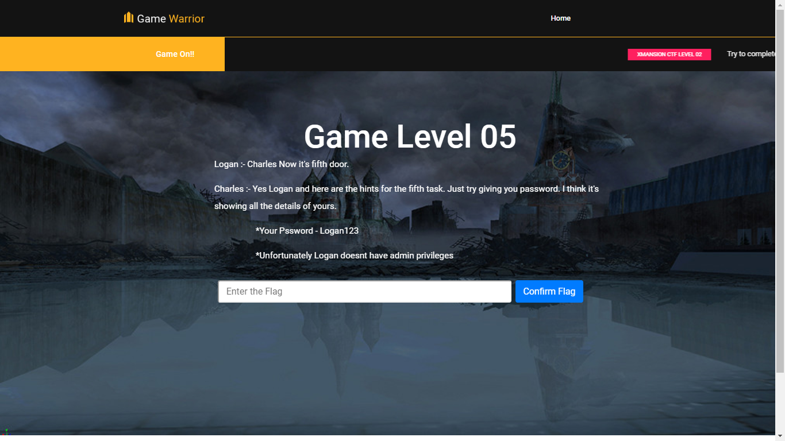

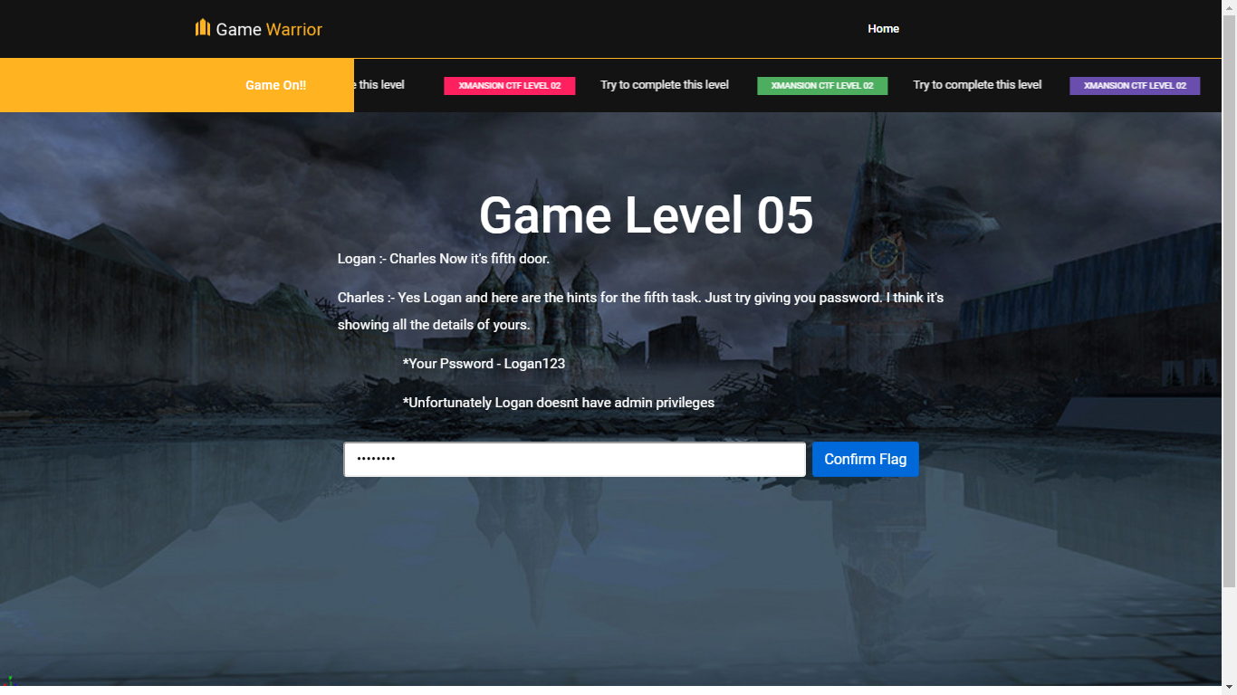

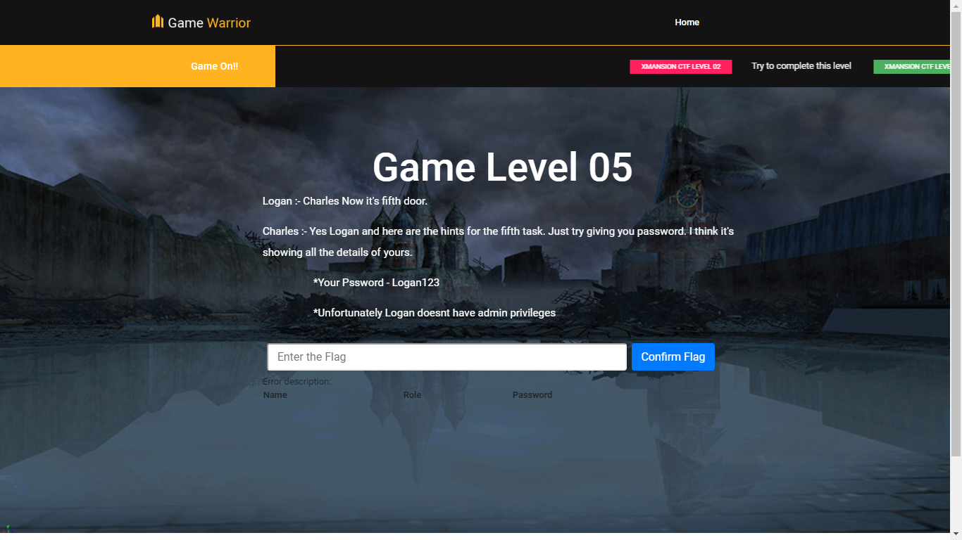

**Logan123’**

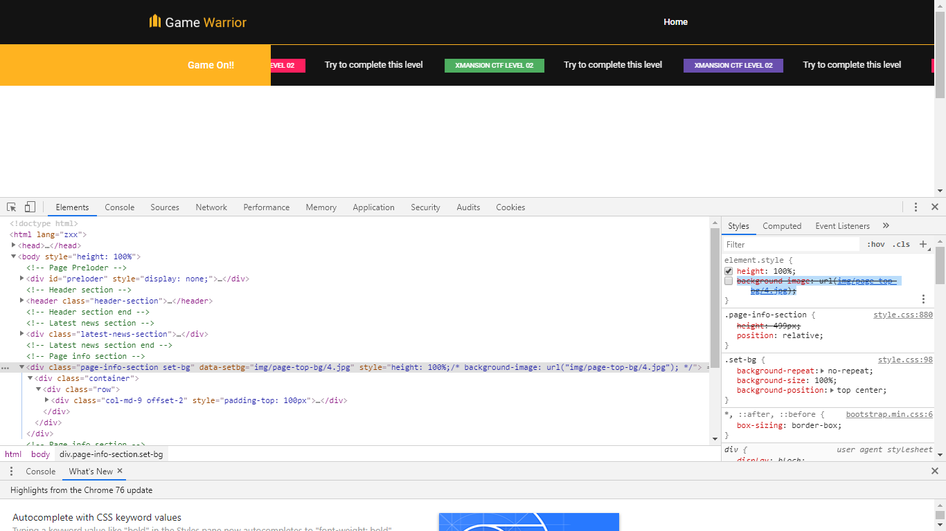

**Logan123' || '1' = '1'**

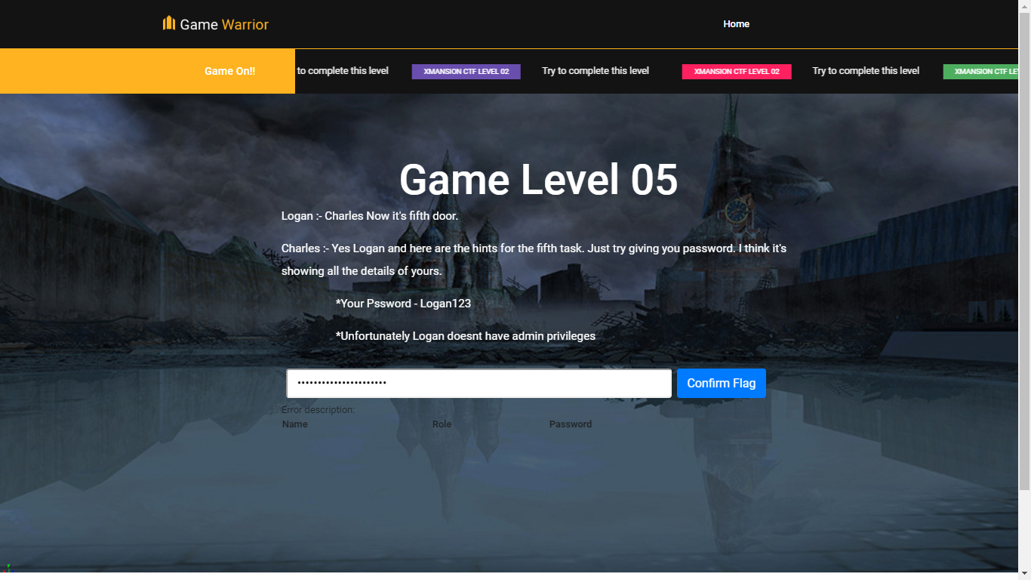

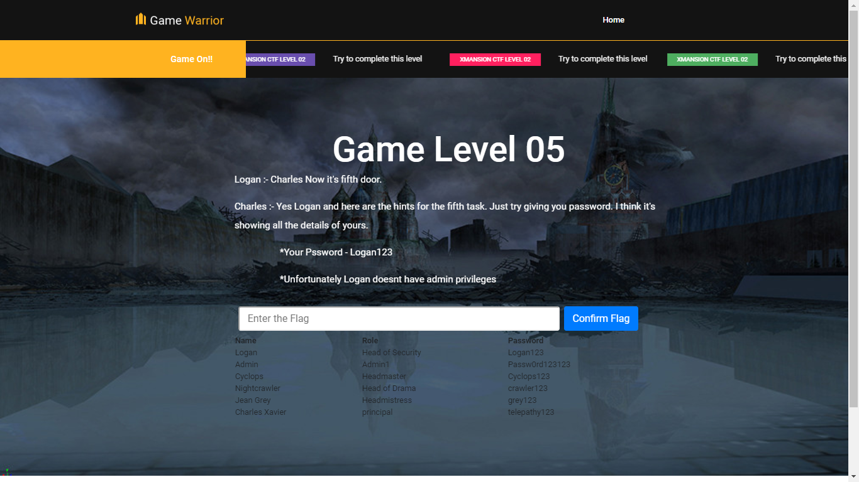

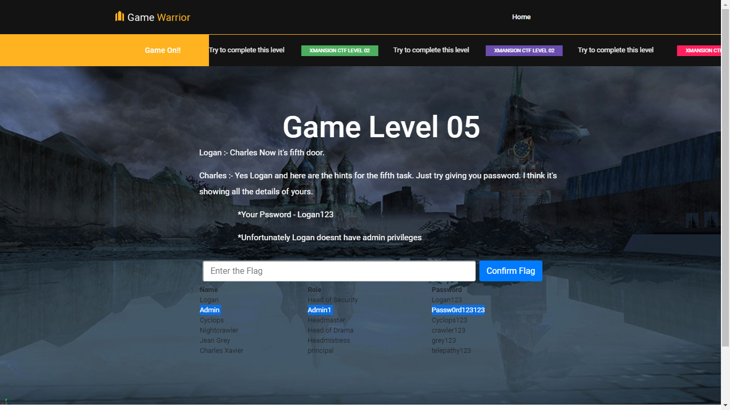

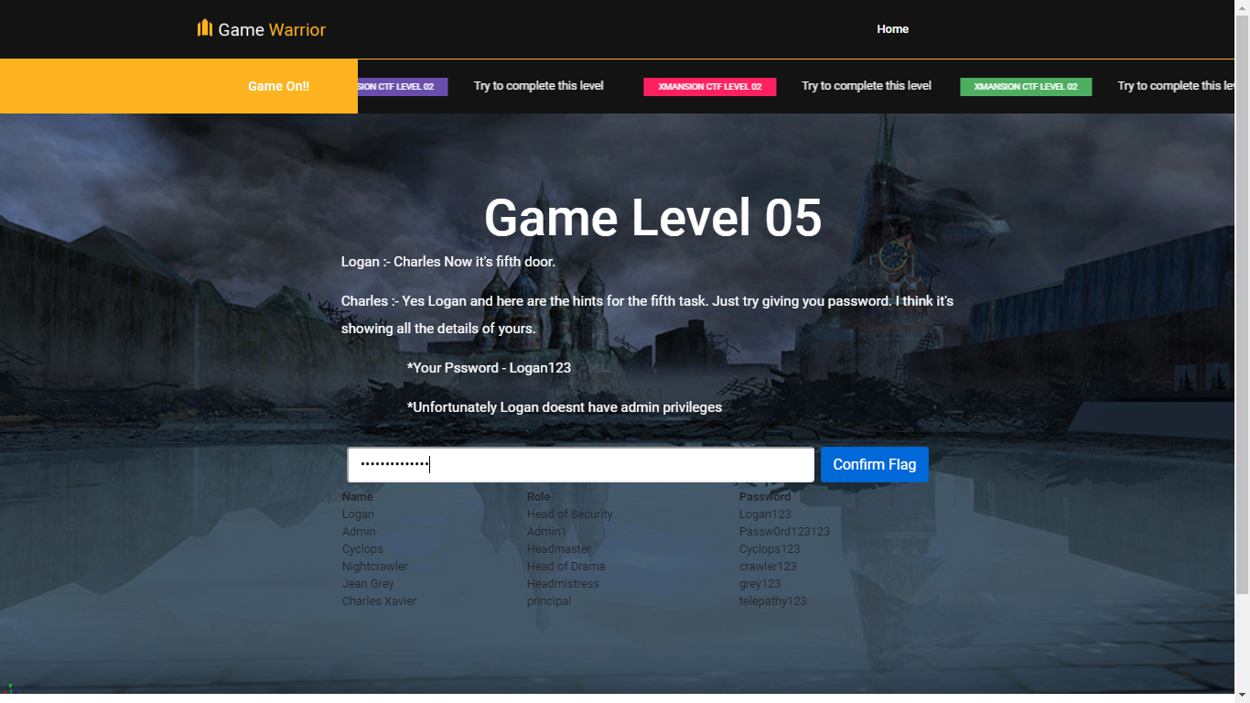

# **Level 06**

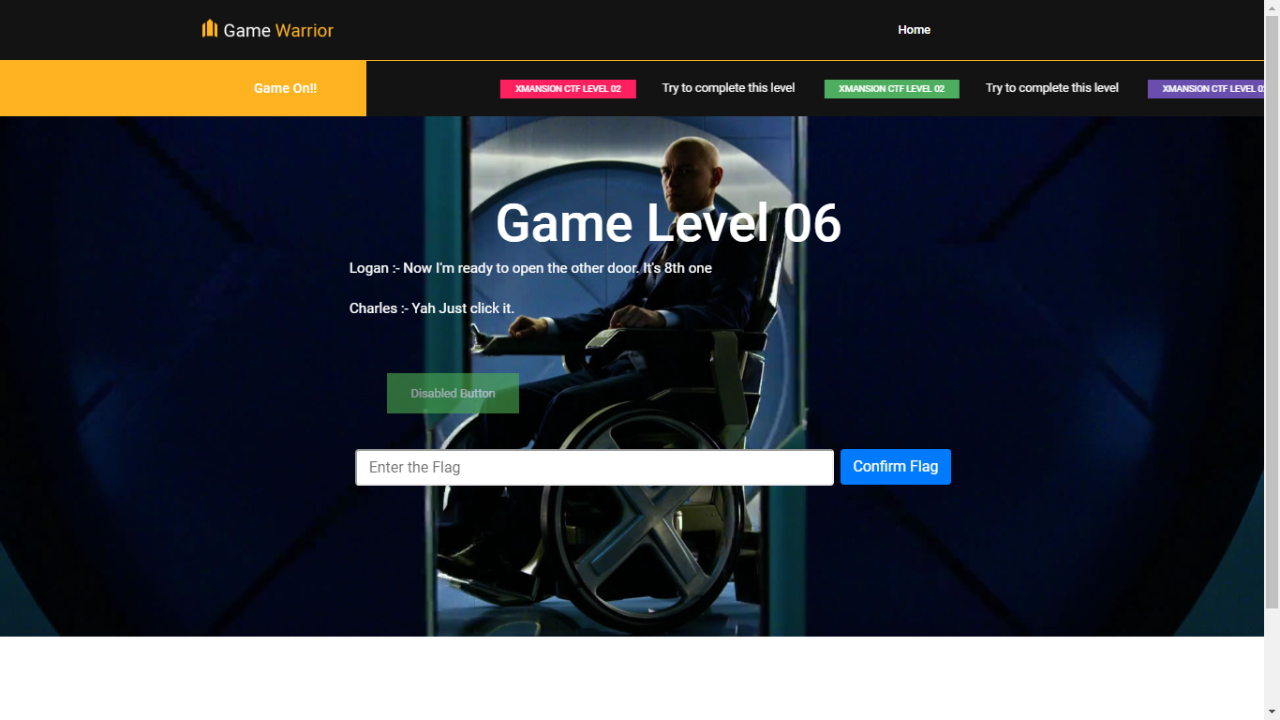

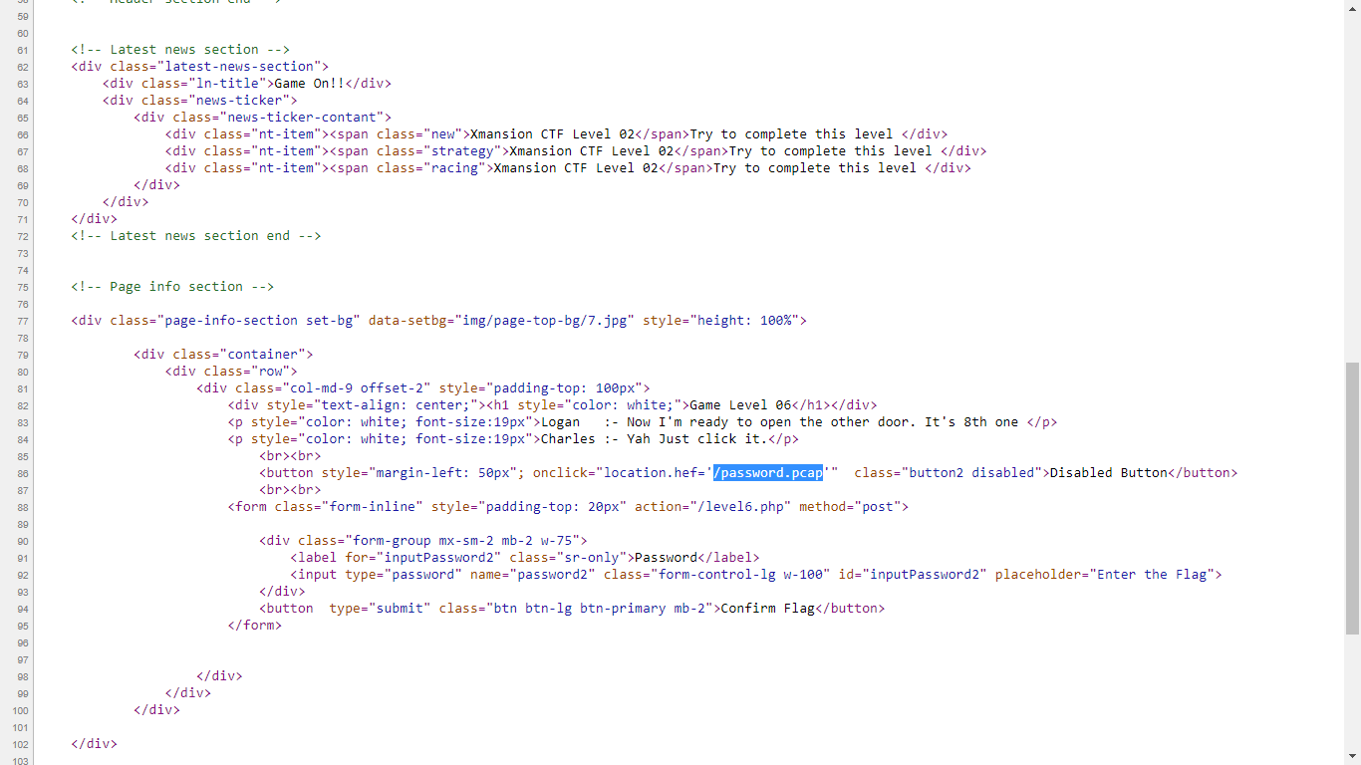

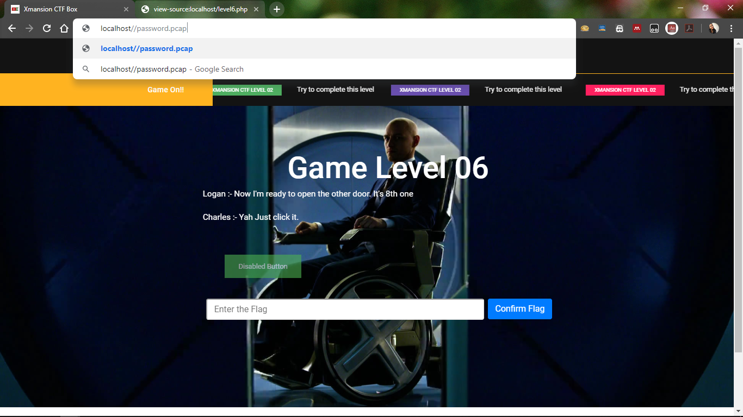

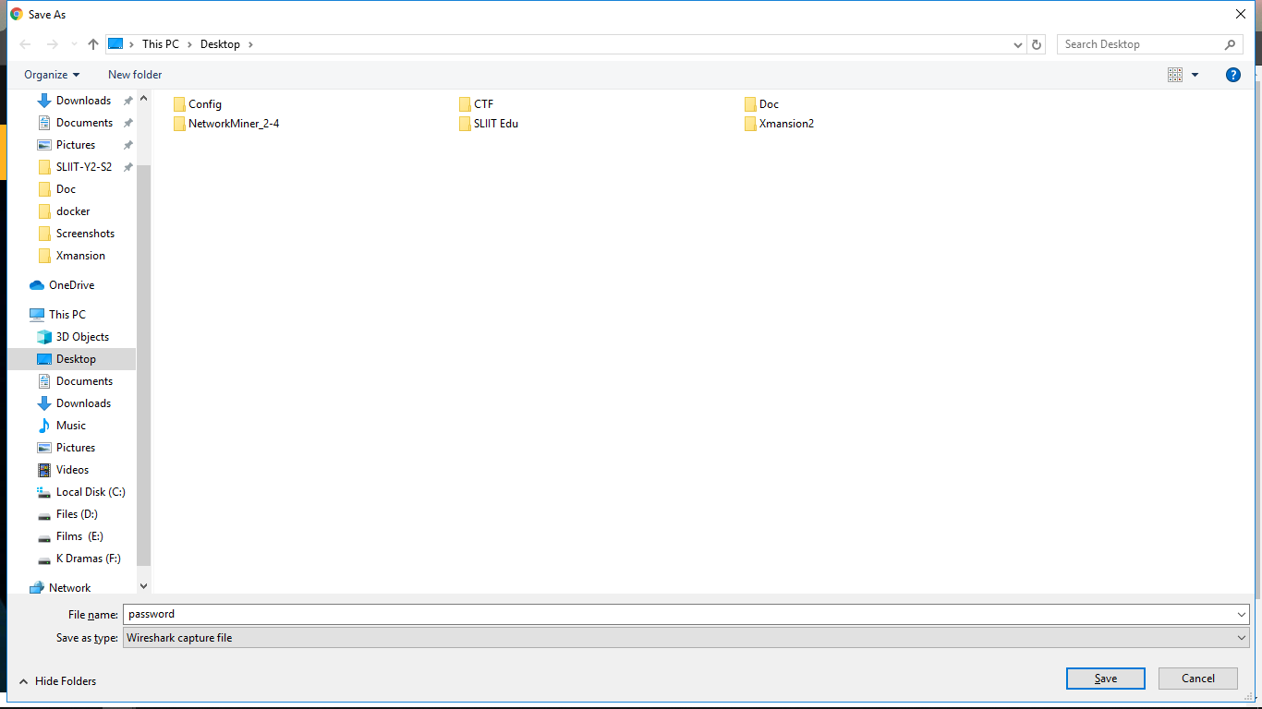

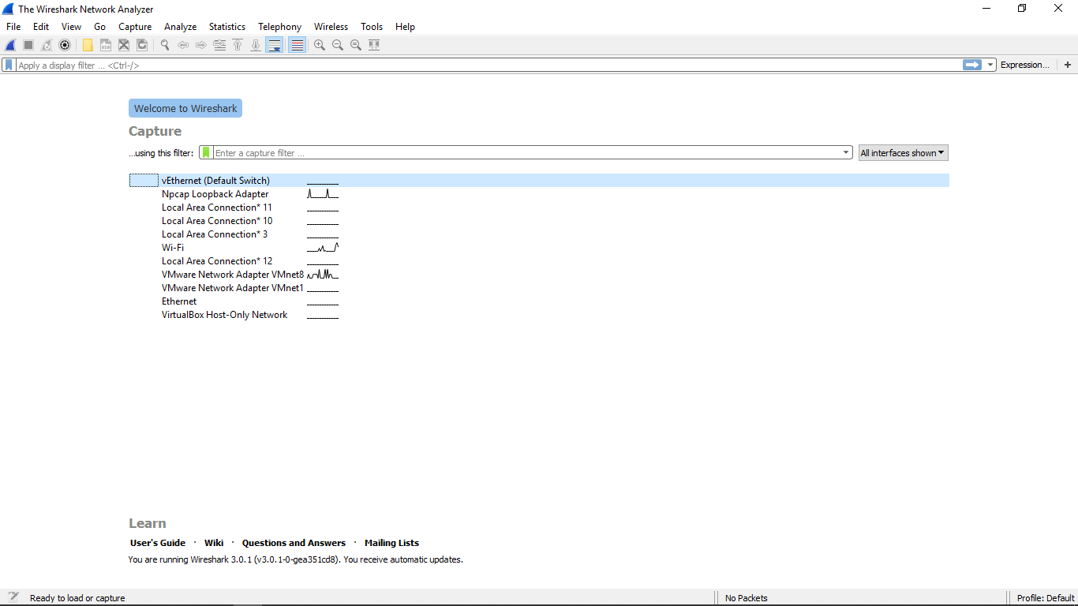

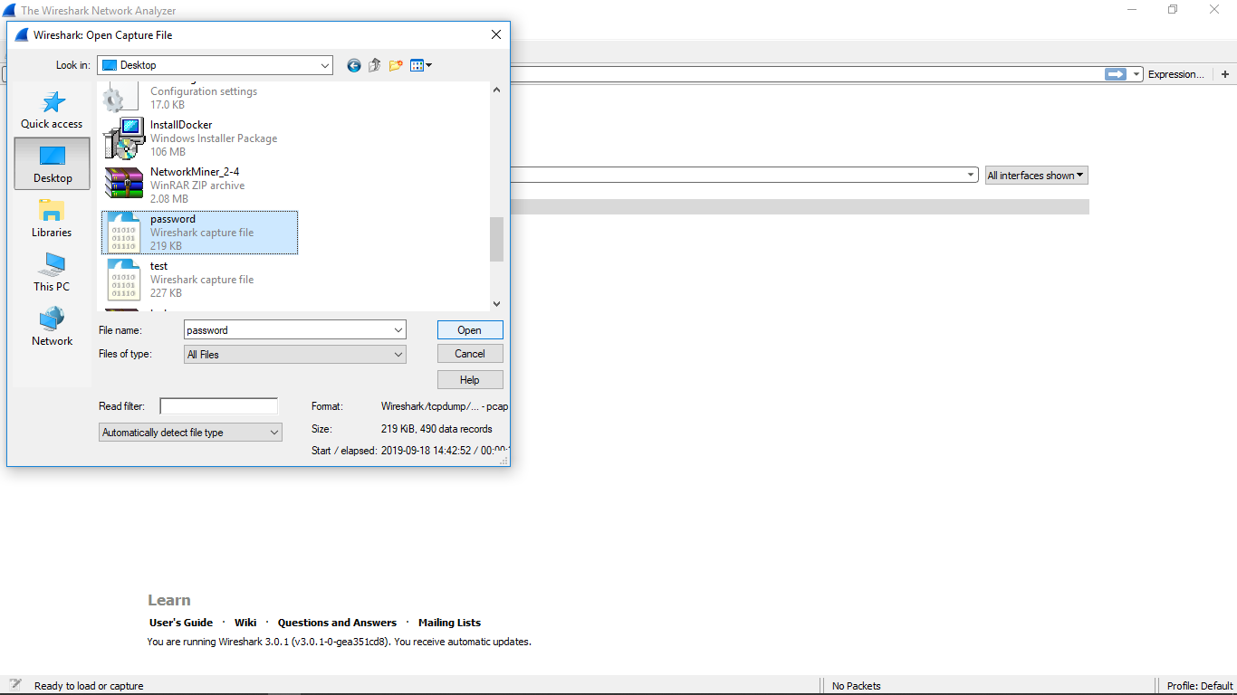

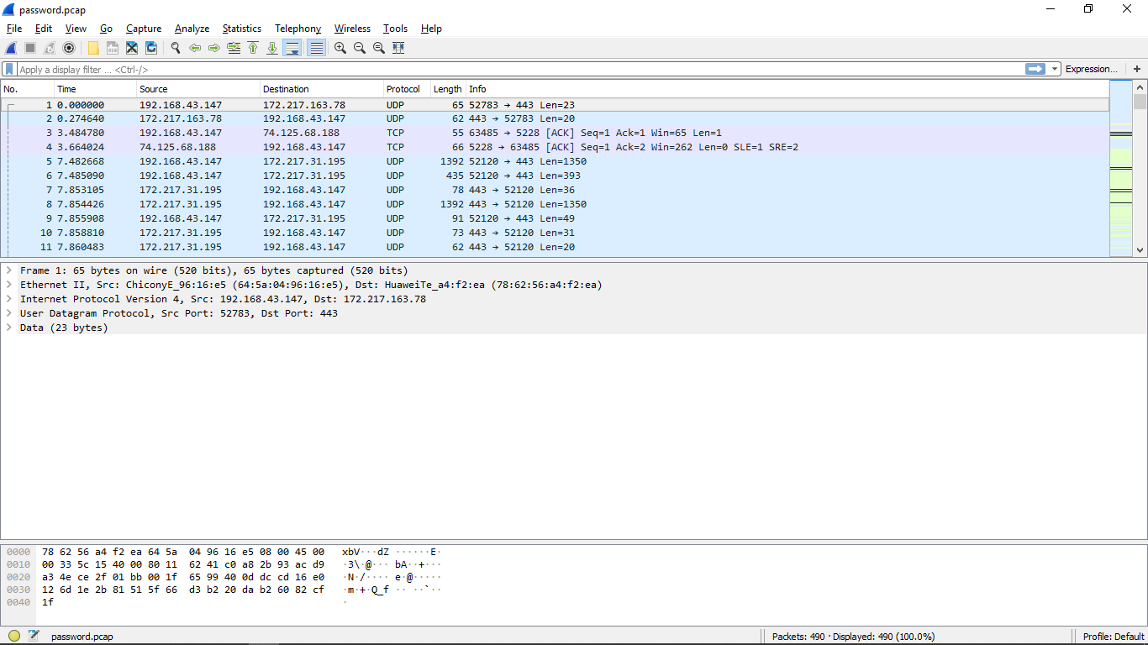

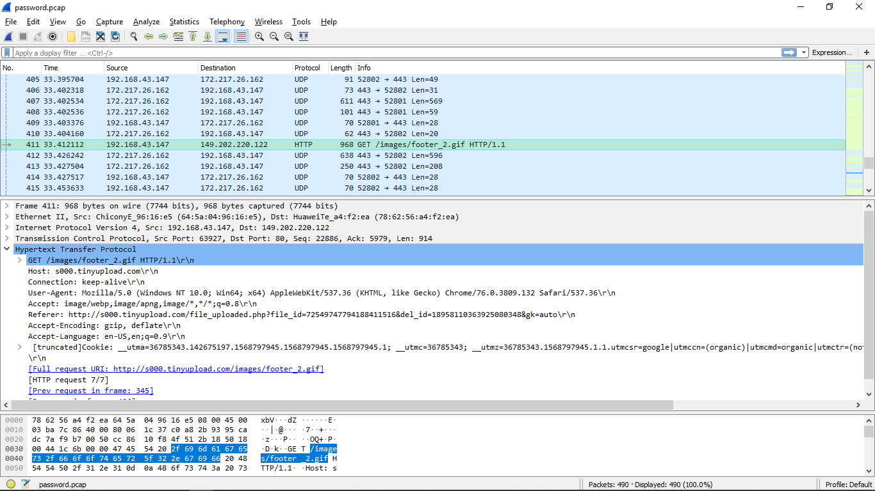

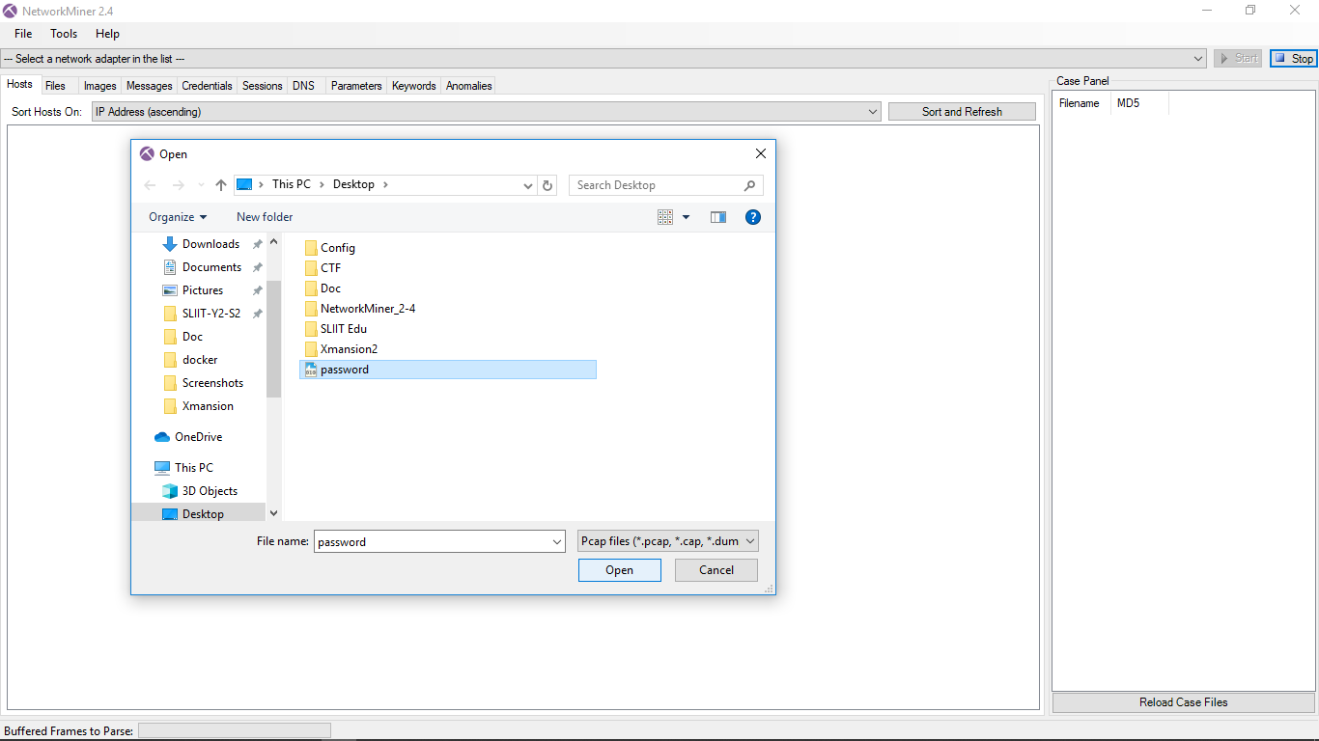

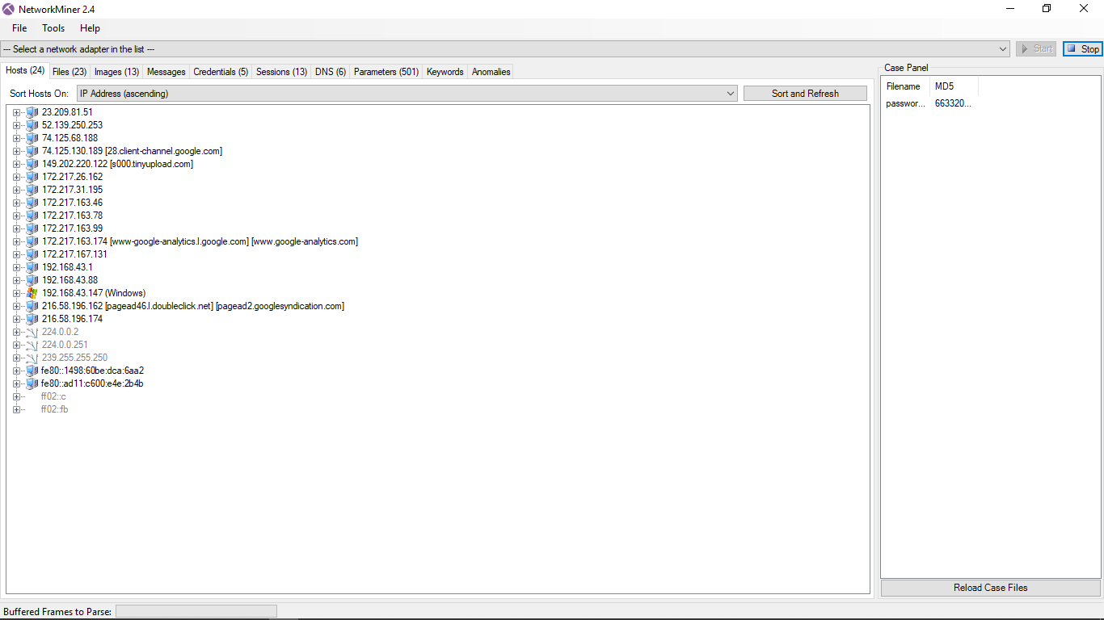

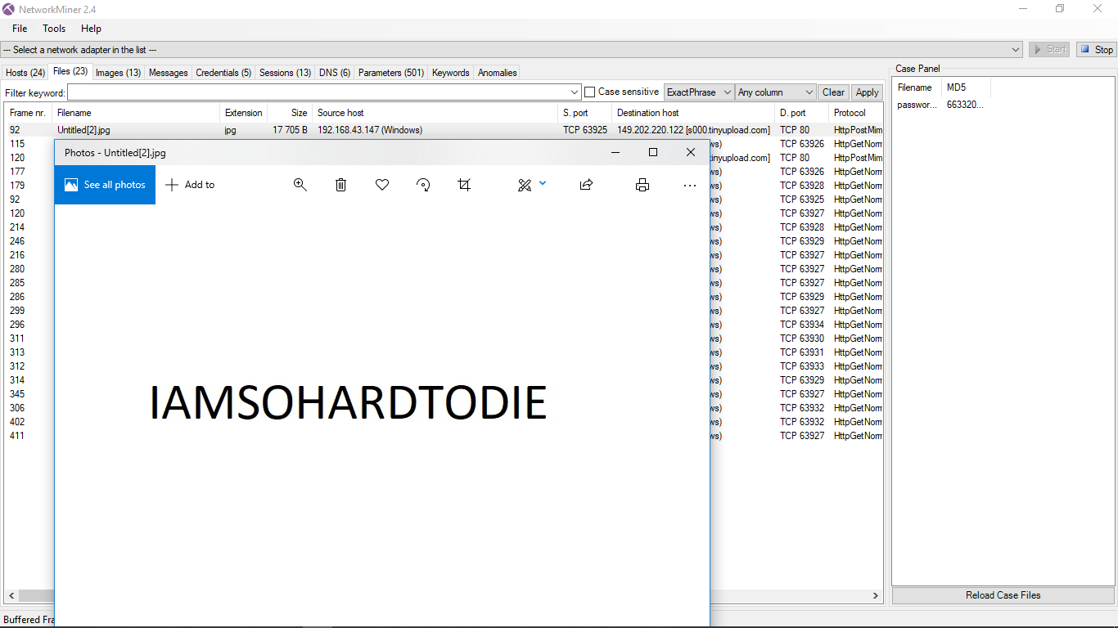

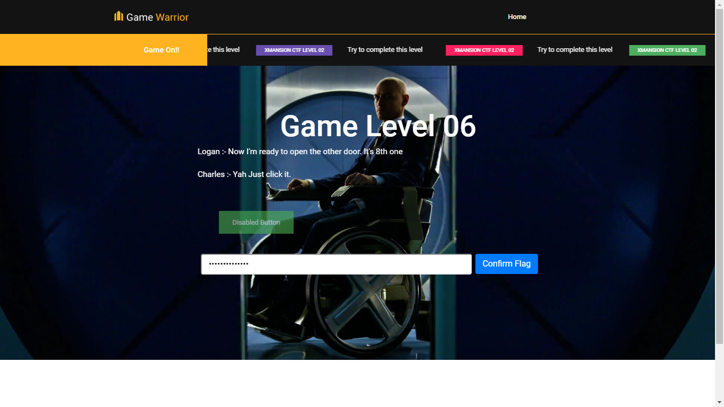

# **Level 07**

# **Level 08**

# **Level 09**

# 

# 

# 

# 

# 

# 

# **Back End**

# **Level 0**

# 

# 

# **Level 1**

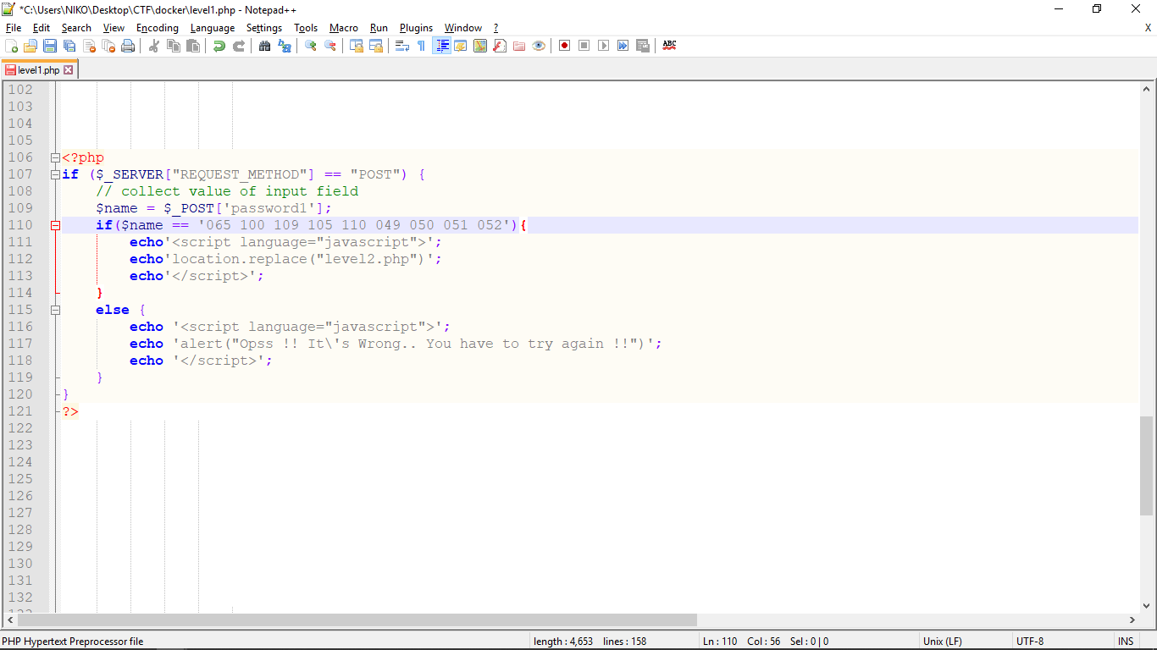

# **Level 2**

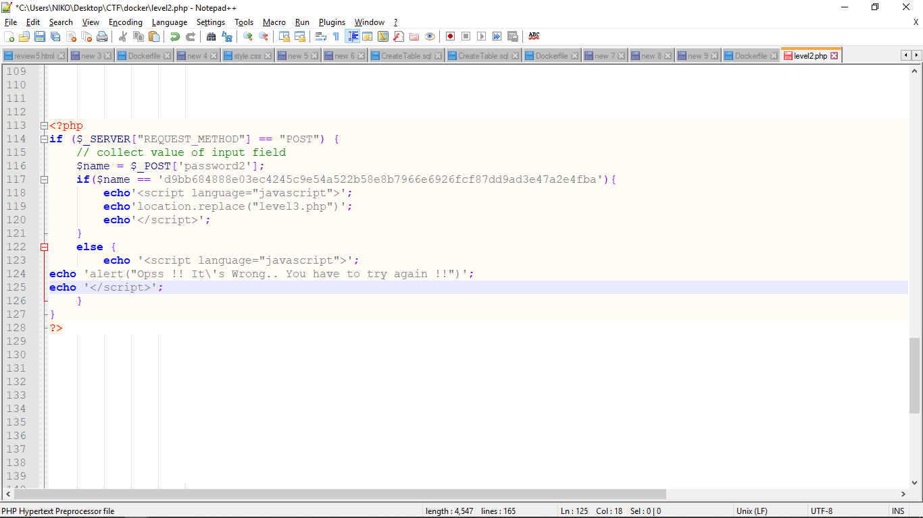

# **Level 3**

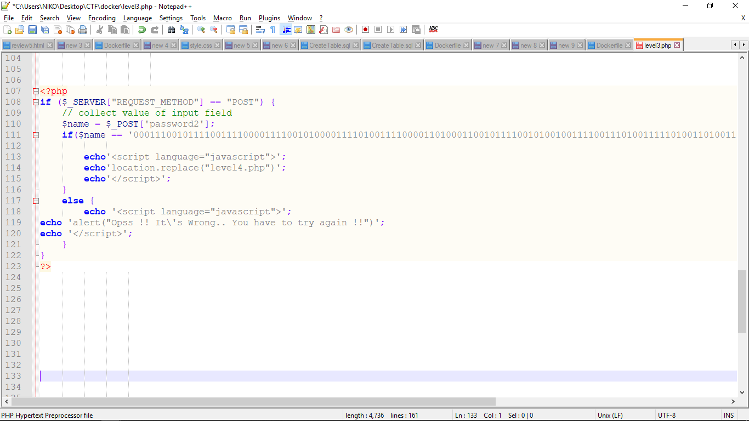

# **Level 4**

# **Level 5**

# **Level 6**

# 